Short term plan
Lesson plan

Unit of a long term plan: Family and friends |  |  | School: 21
Date: |  |  | Teacher name: Shagatayeva Dinash
Class : 1 |  |  | Number present :
Lesson title: |  |  | Family and friends
Learning objectives(s)  that this lesson is  contributing to |  |  | 1.S1.make basic personal statements about people  1.S3.pronouns familiar words expresstions intelligibly  1.UE3. use basic adjective to describe people  1L3.recognize with support common names and names of places recognize the spoken form of a limited range  of basic and everyday classroom words
Lesson objectives |  |  | All learners will be able to:  - pronouns basic words and expressions intelligibly  - name some members of family with teacher’s support  Most learners will be able to:  - match the pictures with sentences  Some learners will be able to:  - describe pictures orally
Assessment criteria |  |  | Learners use adjectives to describe members of family  Learners present a role play of members of family by working with craft activities
Previouse learning |  |  | Learners learned adjectives (big, small)
Value links |  |  | Respect , Cooperation
Cross-Curricular Link |  |  | Self-study, Art, Technology, Primary Science
Use of ICT |  |  | PPT, video, pictures the members of family
Plan
Planned  timings | Planned activities |  |  | Resources
Beginning  5m  5m  Middle  10m  10m  5m  End  5m | Brainstorming  - Learners are suggested a video to watch “a song about family” and guess the topic of the lesson  - Teacher shows the slide show to learners and the learners introduces with the new lexics :  mother  father  brother  sister  grandma  grandpa  - Teacher draws learners’ attention to the board (PPT) and drills the vocabulary in chorus.  T: Well done!  Focuse on : She is …He is a big…  Is he …? L1: Yes, she is  Is he…? L2: No, he isn’t  Who is he? L3:He is a father  Is she…or…? L4: She is….  Teacher organizes to sing a song about family all together  T: Ok! Very good!  - Learners must match pictures the members of family with the appropriate words by working in pairs  M o t h e r  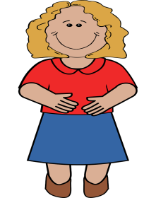  L1: L2:  F a t h e r    L3: L4:  S i s t e r  L5: L6:  B r o t h e r    L7: L8:  G r a n d m a  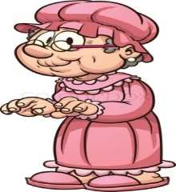 L9: L10:  G r a n d p a    L11: L12:  -Learners do the coloring task and cut out their pictures then do masks for their heads  T: Color picture then cut out it  Take list of paper and fold it twice to make circle  Glue your circle  - They wear masks on their heads demonstrate themselves to each other (pair work)  L1: I am a mother  L2: I am a father etc.  - present a role play to the class naming the members of the family (group work)  L1: I am a mother L2: I am a father  L3: I am a grandma L4: I am a grandpa  L5: I am a sister L6: I am a brother  Teacher asks other learners :  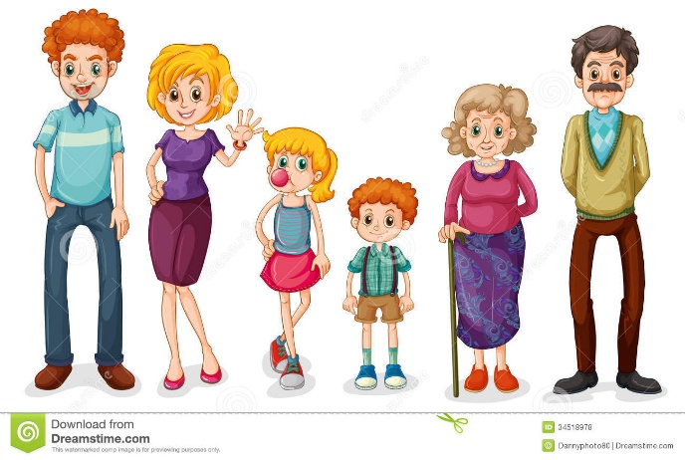  -Is she a mother ? L1: Yes, she is  - Is he a small sister ? L2: No, he isn’t  -Who is he ? L3: He is a father  - Is he a father or grandpa L4: He is a grandpa  Using the same thumbs up motions , ask learners :  T: Did you like the lesson ? L/s:Yes |  |  | Video “Family”  Video “ My family”


Additional information
Differntation – how do you plan to give more support ? How do you plan challenge |  | Assessment – how are you planning to check  learners’ learning ? |  | Cross – curricular links  Health and safety check  ICT links  Values links
more support can be given during elicitation, instruction and questioning phases of the lesson by nominating learners to answer items relating to more high frequency vocabulary to build confidence through participation. |  | - through questioning and the redirecting of  questioning in feedback activities  - through observation |  | - World around us  - Art  -Video  -Active board
Reflection  Were the lesson objectives/learning objectives realistic?  What did the learners learn today?  What was the learning atmosphere like ?  Did my planned differentiation work well? |  | Use the space below to reflect on your lesson. Answer the most relevant questions from the box on the left about your lesson.
-Learning and lesson objectives will be realistic
-Learners will pronouns familiar words and
expressions intelligibly
-Learners ‘ learning atmosphere will be active
-To use craft activities of leaning that had
a special role in learner centered approach
Summary evaluation

What two things went really well ( consider both teaching and learning)?
- Using different techniques of learning
2. Apply variety of skills which will help them not only in their English language lessons but also
in other subjects studied at primary school

What two things would have improved the lesson (consider both teaching and learning)
1.Effective teaching and learning
2.Craft activities

What have I learned from this lesson about the class or individuals that will inform my next lesson?

I have learned to make plan correctly and use different strategies in my lesson in order to make active learners

