ИИН -840515401178
Ватсап телефоны – 87020598484

АТЕНОВА Нургул Нурдилдаевна,
А.С.Пушкин атындағы №1 мектеп-гимназиясының ағылшын тілі пәні мұғалімі.
Шымкент қаласы

THE CENTERVILLE GHOST

Learning objectives | 9.1.9.1 use imagination to express thoughts, ideas, experiences and feelings;  9.2.1.1 understand the main points in unsupported extended talk on a wide range of general and  curricular topics, including talk on a limited range of unfamiliar topics;  9.3.1.1 use formal and informal language registers in their talk on a range of general and curricular topics.
Lesson objectives | Learners will be able to:  - introduce the topic;  - to read for gist;  - listen and read for specific information;  - understand a character's feelings.
Value links | Family – Family values are moral and ethical principles of typical family life, including sacrificing for loved ones, putting your loved ones first, and keeping your loved ones at the centre of your thoughts and actions.
Plan

Stages/Time | Teachers’ actions | Students’ actions | Assessment criteria | Resources
Beginning of the lesson  Warming-up    3 min.  Pre-learning  «Brainstorming» method  7 min. | Organization moment:  Greeting.  Ask about the weather.  The teacher sets the lesson objectives, letting students know what to anticipate from the lesson.  Warming up  Where are you from?  How old are you?  What color is it?  How many students are there in class?  What day of the week today?  Lead – In  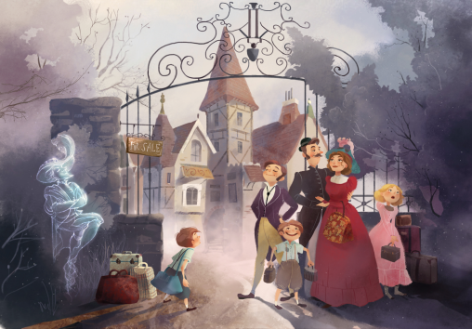 | The aim: To develop pupils speaking skills and create friendly atmosphere  Students of the class are listed.  Students' attention is drawn to the lesson.  Students say different words from the picture  •Learners remember previous lesson vocabulary  •Learners answer the questions | The teacher to assess learners for their ability.  “Good job!  Well done!”  Formative Assessment    Good job!  Descriptor:  - remembers the lesson passed  Point 1  Assessment criteria  make basic statements related to personal information, people and objects | Pictures  worksheet  Picture
Middle of the lesson  Presentation part  30 min. | Ex:1 P:54  • Elicit what, if anything, Ss know about Oscar Wilde and the stories he wrote.  Direct Ss to the picture and the biography of Oscar Wilde and ask them to read the biography and answer the questions.  Elicit answers from Ss around the class  Ex: 2 P: 54  • Ask Ss to look at the pictures and elicit their guesses as to whether the people in the pictures are afraid of the ghost or not.  Play the recording.  Ss listen and read the text to find out.  Check Ss' answers.  Ex: 3 P: 54  • Give Ss time to read the text again and the sentences. Then, Ss mark them as true, false or doesn't say.  Check Ss' answers.  Ex: 5 P: 55  • Give Ss time to match the words in the column to form phrases from the text.  Check Ss' answers.  Ex: 6 P: 55  • Explain the task. Ss complete the task and check their answers in the text  Ex: 7 P: 55  • Allow Ss time to look up the meanings of the words in the list in their dictionaries if necessary.  Elicit definitions from Ss around the class.  Then give Ss time to use them to complete the sentences.  Check Ss answers.  Conclusion during the lesson some tasks differentiated by outcomes of the students and by their abilities. | • Learners read the biography. Answer the question.  ANSWERS  Oscar Wilde wrote a lot of literature: poems, articles for magazines and newspapers, collections of fairy tales, several funny plays and a novel. The Canterville Ghost is a novella with elements of both comedy and horror  • Learners look at the pictures. Answer the question.  ANSWERS  The people in the pictures are not afraid of the Canterville Ghost.  • Learners read the extract and mark the statements.  ANSWERS  1F 2 F 3 F 4 DS 5 T  • Learners match the columns  ANSWERS  1 b 2 d 3 e 4a 5c  • Learners choose the correct item  ANSWERS  1 in 2 to 3 at 4 down  5 onto  • Learners complete the sentences. Use the words in the box  ANSWERS  1 rude 2 afraid  3 clank 4 insulted  5 sight | Descriptor:  - read the biography.  - answer the question  Total: 2 point  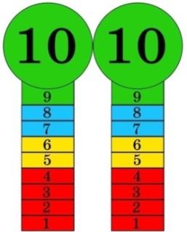  Self assessment  Differentiation: «Verbal support» method is used to help Ss use new words in the sentences.  Descriptor:  - read the extract  - mark the statements.  Total: 2 point  Descriptor:  - match the columns  Total: 1 point  Descriptor:  - choose the correct item  Total: 1 point  Descriptor:  - complete the sentences.  - Use the words in the box  Total: 1 point  -Make CCQ questions Yes / No |   Card  Worksheet  Students book
End of the lesson  5 min. | FEEDBACK  Learners provide feedback on what they have learned at the lesson.  Ex: P:  Home task:  Write the days | 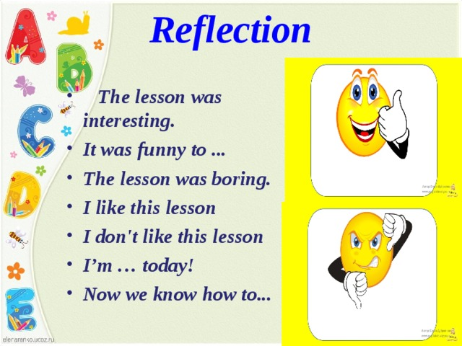 |  | Poster Success  

