**ЖСН ИИН: 880630401864**

**НАРКУЛОВ Асадбек,**

**№28 «Ақбай» жалпы білім беретін мектебінің оқушысы.**

**Жетекшісі: АНАРКУЛОВА Нигора Зияьековна.**

**Түркістан облысы, Сайрам ауданы**

**THE 12 BEST WEBSITES TO LEARN ENGLISH IN 2024**

Want to improve your English language skills online? View our picks of the best websites for learning English and get started today. Want to improve your language skills quickly and at times that work for you? Luckily, there is no shortage of websites to learn English, but finding a quality platform that suits your particular needs can be tricky.

We’ve researched and assessed a selection of the best websites to learn English overall and for different requirements. View our list below to find your perfect match today.

## Best website to learn English overall Preply

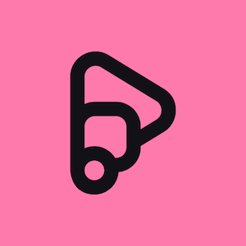Preply is a language learning platform that helps you get engaging, tailor-made classes that cover all aspects of English. Using Preply’s innovative search filters, you can quickly find [online English tutors](https://preply.com/en/online/english-tutors) within your budget who have a specific accent, specialize in a particular area, and are available to give lessons when you want.

All the 11,000+ English tutors in Preply’s global network focus on getting you speaking to ensure you level up fast. In a survey of Preply students, 83% of respondents agreed that “Learning with a Preply tutor is the most effective way to achieve their goals.”

### British CouncilОписание: https://preply.com/wp-content/uploads/2022/08/unnamed-48-300x300.png

Despite initially only providing in-person Engish lessons via its schools, the [British Council](https://learnopoly.com/british-council-learnenglish-review/) now has an online language learning platform offering free classes. Its “Live25 sessions” cover various grammar points, such as modals of ability and superlatives, at set times during the week.

These 25-minute presentations are given by real-life tutors and let you ask questions via the live chat function. But despite claiming to be “free,” you must first attend a group or private class before you can book a “Live25 session”. The British Council self-study platform costs £5.99 (about $7.30) per month.

Dave’s ESL Cafe

Although Dave’s ESL Cafe is primarily a forum for teachers and students, the site has free educational materials. You can access short grammar explanations, pages containing definitions of English slang, and multiple-choice quizzes.

Yet because this website’s target audience is English tutors, most of the resources are lesson plans, and its forum only features topics for tutors. It also has a “Find a teacher” function, but it’s mainly for schools and costs $75 to post an ad. Still, Dave’s ESL Cafe is worth visiting if you want to practice doing short exam questions.

### BBC Learning English

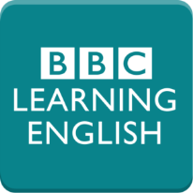The BBC has been helping people learn languages since 1943. Consequently, it’s unsurprising that its website, [BBC Learning English](https://www.bbc.co.uk/learningenglish/), gives you access to quality educational materials.

It has video lessons, radio shows, multiple-choice quizzes, and articles that cover various topics, including news stories, strange vocabulary, and pronunciation. Unfortunately, there are no interactive speaking classes. But for people who only want a self-study course, this is one of the best free websites for learning English.

### Duolingo

When you think of learning English online, Duolingo’s jolly green owl probably comes to mind. This famous language learning platform provides various activities, such as fill-in-the-blanks, multiple-choice, and flashcards.

Its game-like approach to learning has made it extremely popular. By challenging you to complete lessons to maintain “streaks” (consecutive days of studying), [Duolingo](https://www.pcmag.com/reviews/duolingo" \t "_blank) motivates you to keep learning new vocabulary and phrases.

### Memrise

This language-learning platform has various tools to help you learn new vocab. Alongside its multiple-choice questions, typing tests, and activities to boost your listening skills,[Memrise](https://www.studyfrenchspanish.com/memrise-review/) offers “classic reviews” and “speed reviews” to help you remember new words. It also tracks your progress with flower images that grow every time you answer correctly.

The free version of Memrise gives you limited access to its services, but you must pay to benefit from all of its features. A “Premium Membership” costs $8.49 a month, $29.99 a year, or $119.99 for a lifetime subscription.

ABCya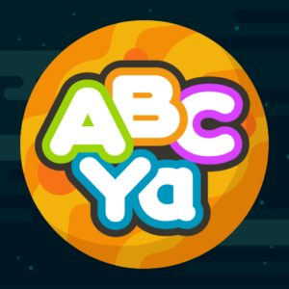

This brightly colored website focuses on making learning fun for young kids. [ABCya](https://www.abcya.com/" \t "_blank) has entertaining games for different age groups that cover various topics, including English grammar, maths, and geography. Along with game-style quizzes, it has online tools that let students engage in digital storytelling.This interactive approach to self-study can help encourage children to independently improve their English language skills outside the classroom.

Cambridge English

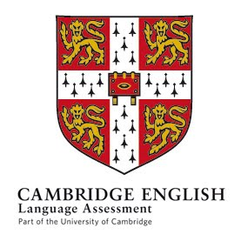[Cambridge English](https://www.cambridgeenglish.org/) is perfect for young language learners and students who want to study for Cambridge English exams. Its online reading, writing, listening, speaking, grammar, and vocabulary activities include fun sing-along lessons for young learners and games they can access online.

Activities for older kids take five to 10 minutes to complete —  these are perfect for short attention spans.

## Websites for learning English grammar

Want to learn more about conditional sentences or understand the difference between relative and non-relative clauses? These online language learning platforms specialize in helping students learn new grammar points.

### Babbel

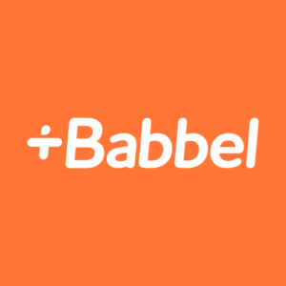Along with teaching students vocabulary for everyday conversations, Babbel also provides users with helpful grammar explanations in their native languages. This feature can help you better understand grammatical concepts, especially if you’re a beginner.

Once you’ve learned new grammar or vocab, Babbel lets you test your knowledge with quick quizzes and games, which you can access via its app or website.

### FluentU

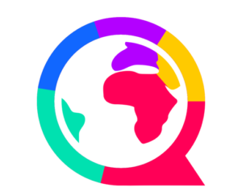

[FluentU](https://www.perapera.org/fluentu-review/#:~:text=Although%20FluentU%20is%20an%20excellent,the%20language%20you're%20learning.) teaches students grammar concepts through video content arranged by level, format, and topic. Each video features subtitles that you can click on to see short definitions and explanations of the sentence structure.

Because all the information is contextual, it can help you understand grammar points more quickly than textbook descriptions. Yet as it lacks any tutor guidance, it can be challenging for users to know whether they’ve fully understood the explanations. Nevertheless, it’s one of the best websites to learn English if you enjoy watching clips of series and movies.

### VOA Learning English



Initially launching as Special English in 1959, the Voice of America rebranded its platform in 2014 as VOA Learning English when it went online. Now users can access a range of textbook-style reading and listening exercises based on current global events.

Moreover, you can also watch short videos that give you English pronunciation tips and tell you the difference between commonly confused verbs.

TED

Famous for its “[TED Talks](https://www.ted.com/talks)” —  presentations on science, self-help, finance, philosophy, and other fascinating topics — this educational platform also has an excellent website for learning English and other languages.

On the TED-Ed website, you can take various video-based lessons that test your understanding of presentations with multiple-choice questions. You can also [access full transcripts](https://help.ted.com/hc/en-us/articles/360018572954-How-do-I-find-transcripts-for-TED-and-TEDx-talks-) of each talk to review any new grammar and vocabulary.

## What to choose to start?

There are more quality websites to learn English than ever before. Yet because most of them cater to a broad audience, they rarely provide materials designed to help you achieve your individual language learning goals.

With Preply, you can access a vast network of native English-speaking tutors. You can find one with the proper accent and expertise to give you classes designed for your needs and level in minutes. Combining this with the self-study materials available in the Preply library is the most effective and efficient way to progress in English.

Sign up with Preply to take[personalized English classes](https://preply.com/en/online/english-tutors) with an expert tutor today.